
Relative Clauses: Restrictive and Non-restrictive
Relative clauses add additional information about just one part of a sentence. They can come in one of two forms: restrictive or non-restrictive. These two forms can easily be distinguished by the way they do or don’t use commas. However, confusing the two types of relative clauses can evoke unintended meanings for your reader. Practice examples are on the next page of this handout.

You need 3 things to create a relative clause in a complex sentence:
- Independent Clause — This standalone sentence contains a noun that the relative clause will modify, either restrictively or non-restrictively, as well as a verb of its own.
- Relative pronoun (RP) — a word like that, which, where, who, or whom that connects the noun from the independent clause to the verb in the relative clause that modifies it.
(Note: “which” is only used in non-restrictive clauses)
- A main verb in the relative clause — Having a main verb is what distinguishes a phrase from a clause, so in order to create a relative clause there must be a verb used to describe the noun from the independent clause.
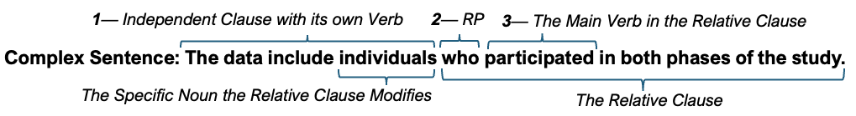

Restrictive Clauses
Restrictive Clauses restrict a larger potential group to a narrower subset by adding additional qualifiers. Removing them changes the meaning of the original sentence. They are NOT surrounded by commas.

Example:
*Focus group participants who have already confirmed their survey participation eligibility are invited to complete an additional survey in exchange for a $20 gift card.
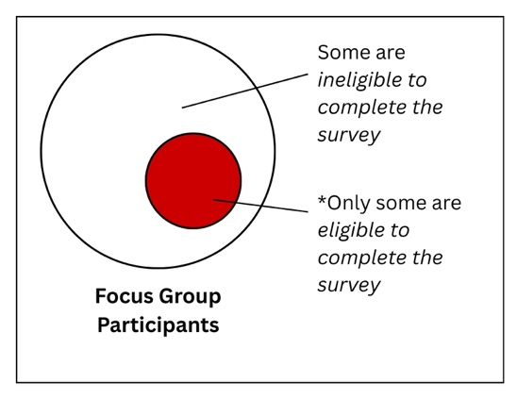

Non-Restrictive Clauses
Non-restrictive clauses, sometimes called appositive clauses, add additional or clarifying information that applies to all of whatever the clause describes. Adding/removing these clauses does not change the original meaning of the independent clause. They ARE surrounded by commas.

Example:
**Focus group participants, who have already confirmed their survey participation eligibility, are invited to complete an additional survey in exchange for a $20 gift card.
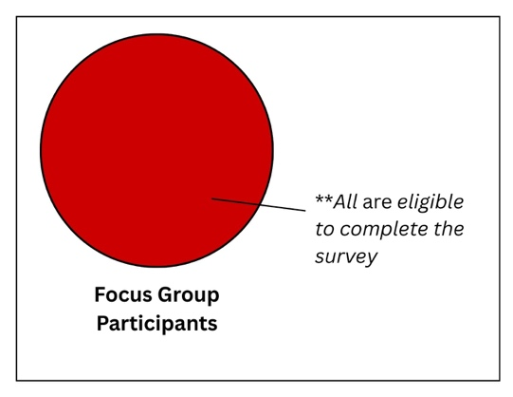

Relative Clause Practice
Below are several examples of relative clauses in complex sentences for you to practice with. Please select the most appropriate pronoun or punctuation choice from the options provided. Explanations are at the bottom of the page.
- Grades, that/which will be posted on Blackboard, will be available on Friday.
- Samples that/which have already been processed will be stored at 0℃ until the completion of Phase 1.
- Results indicate three variables that/which significantly influenced outcomes in the experiment.
- Scholars (commas/no commas) who study the interactions between the physical aspects of a region and the human activities within it¹ are called geographers.
- Scholars (commas/no commas) who devote their careers to furthering knowledge within their discipline are often found in academia.

Explanations
- Which (non-restrictive): Commas let us know that this is a non-restrictive clause, which requires “which” rather than “that.” Using “which” implies that all grades will be both posted on Blackboard (because “which” does not place any restrictions on grades) and available on Friday. Using “that” would restrict the group of grades to a potentially smaller set that would be posted on Blackboard (vs. other locations perhaps) and would require that the commas be removed from the sentence.
- That (restrictive): Not using commas lets us know that this is a restrictive clause. Written in this way, this sentence tells us that the group of samples that have been processed may be a smaller set than the whole group of samples and that this smaller set of already processed samples will be stored at 0℃. If we wanted to imply that all samples would be processed together, we could rephrase this sentence to “After processing, samples will be stored at 0℃ until the completion of phase 1.”
- That (restrictive): In this case, it is important to add qualifications to “three variables.” Using “which” would imply that we could understand the implications of these variables without the addition of “significantly influenced outcomes in the experiment,” but the thought is incomplete without this information. The use of “which” would also require commas.
- No commas (i.e., restrictive clause): Not all scholars are geographers, so we have to use a restrictive clause to limit the group of scholars to those who study “interactions between the physical aspects of a region and the human activities within it” in order to describe them as geographers. Using commas would imply that we could remove the whole underlined clause without changing the meaning, creating the sentence “Scholars are called geographers,” which excludes other types of scholarship.
- Either! But they create different meanings: The sentence “Scholars are often found in academia” can stand alone, so adding commas (making it non-restrictive) would make the clause “who devote their careers to furthering knowledge within their discipline” almost an aside that is being applied to all scholars. Leaving the commas off (making it restrictive) suggests that there is a subset of scholars that devote their careers in this way and that that subset, rather than all scholars, are the ones often found in academia. In cases like this, it is important to consider the nuances of your own intended meaning.

- This description comes from the U.S. BUREAU OF LABOR STATISTICS Occupational Outlook Handbook found at https://www.bls.gov/ooh/life-physical-and-social-science/geographers.htm

