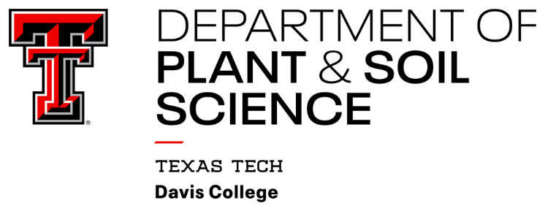

Davis College of Agricultural Sciences & Natural Resources

Department of Plant & Soil Science

MS 2122

Lubbock, TX 79409-2122