How to check your schedule

- TTU MyTech Tab--> Manage my enrollment--> Select "Current term"

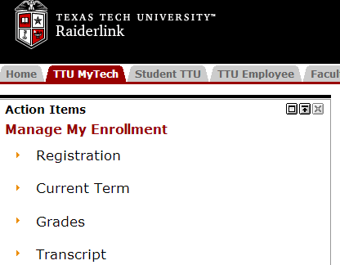

- From the “current term” menu, select "concise student schedule."

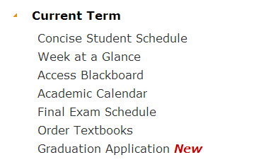

- Select the relevant term and click submit. Your "concise student schedule" will appear on the next screen.
