Tips for Notetaking

Part I: Why Do We Need Notetakers?

What is Note Taking?
Note taking is creating a written record of the main points and supporting details of a class, including:
- Lectures
- Class discussions
- Demonstrations, such as labs
- Videos or films shown in class
Even the best notes are not a word-for-word record of everything said by the teacher and others in the class. However, notes should include all learning points as well as other important information such as assignments, class announcements, and test dates.

Notetaking as an Accommodation
It can be difficult for students with a variety of disabilities to focus on a classroom lecture and take notes at the same time. These disabilities include but are not limited to:
- Hearing loss
- Vision loss
- Learning disabilities
- Attention Deficit Disorder (ADD) or Attention Deficit Hyperactivity Disorder (ADHD)
Because the government recognizes that note taking presents a barrier for students with these and other disabilities, there are laws that require schools to provide note taking for these students to give them equal access to instruction during and after class.

Note Taking for Others
How is note taking for other students different from taking notes for yourself?
When you know that someone else will be using your notes, especially students with hearing loss, you must be extra careful to record all vital information completely.
Even if the teacher says something that you already know, you must include it in the notes.
This means including things like:
- Major topics or themes
- Basic concepts
- New or difficult vocabulary
- Assignments
- Class announcements
- Test, quiz, and project due dates

Part II: Preparing to Take Notes

Gathering Supplies
There are two aspects to taking good class notes:
- Understanding the information that is being taught
- Recording that information in a clear and useful form
But first, look at the supplies you need to do this.
One difference in taking notes for students with a hearing loss is that the notes will need to be copied. This can be done in a variety of ways:
- Photocopying
- NCR paper – This is a carbonless "bundle" that copies what is written on the top sheet onto the pages below. You may have used NCR paper while filling out an application form. With NCR paper the notetaker simply pulls the sheets apart. The notetaker keeps the bottom copy and gives the top copy to the student.
- Electronic format – notes can be scanned into a computer and provided to the student in an electronic format.
Whatever method is used, it is important that notetakers have the right materials to do the job well.

What if My Professor Puts Information Online?
- Today, you will find many professors who put their notes on the school’s course management system, such as Blackboard. That does not mean that you should tune out and take a nap!
- Make sure you have printed out a copy of the notes and bring them to class with you.
- This is a great chance to focus on what is being said and supplement the notes with key points, examples, and main ideas.
- Use the professors verbal and non-verbal cues to help you decide what and where to supplement the notes.
- Use a system of abbreviations and symbols to point out important material.

How to Select Your Note Taking Method
Classes that are heavy on numbers, equations, and formulas are best suited for handwritten notes.
However, if you select to use a laptop, always have a notebook available to copy visual information that is difficult to duplicate on a laptop (just in case).
For courses that are heavy on information presented during the lecture, note taking on a laptop allows for quicker recording.

Tips When Using a Laptop
- Use formatting like bolding, underlining, and italicizing to emphasize key information. Using keyboard shortcuts can increase efficiency. A list of keyboard shortcuts for Windows OS is provided online.
- The keyboard shortcuts for Mac OS are also provided online.
- Sometimes professors will upload their PowerPoint presentations prior to class. It can be helpful to download these notes and review them before class. A laptop allows the notetaker to directly expand on the professor's notes (within the document itself) and acts as a note taking guide.
- Save your notes frequently. (Ctrl+S) It may also be beneficial to save them to an online platform to prevent loss of your work if there is an issue with the computer.

Part III: Note Taking Skills

Knowing What's Important
Often instructors use jokes, anecdotes, stories, or observations to make the class more interesting and lively.
The goal for the notetaker is to identify what the teacher says that must be included in the notes. These phrases can clue you in that important information is coming:
- "Now this is important . . ."
- "Remember that . . ."
- "The important idea is . . ."
- "The basic concept here is . . ."
- "You'll need to remember this."
- "You'll need to understand this before you can move on to that."
- "This will be on the test."

What's on the Notes Page?
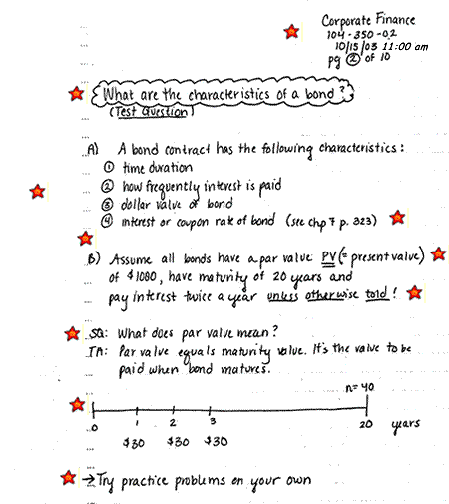

* View the “Structuring Your Notes” document on the SDS Notetaking page for details about the starred portions. *

Cleaning Up
Before handing off your notes, you should go back and check that they are complete, correct, and clear.
When you clean up, you should:
- Check spelling.
- Label and indicate important information.
- Add key concepts to two-and three-column notes.
- Rewrite any sloppy or illegible words.
- Make sure any false starts or material to be ignored is completely crossed out.
- Add headings or number lists to provide additional structure.

