Using BBCU Tools

- Once you click on the link, you will be prompted to enter your name. Click “Join Session.”
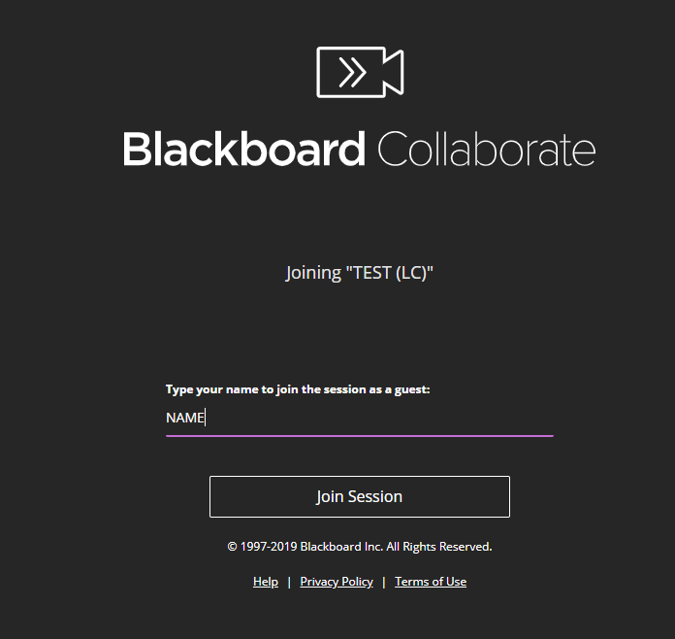

- Make sure that your microphone and speakers are working correctly. You may be prompted to give BBCU permission to access your microphone. Please do so.

- You will be taken to the “Virtual LC” where the student assistant (SA) will get you set up with a tutor.

- By opening the purple tab at the bottom right of the screen, you can control the access panel to your tools.
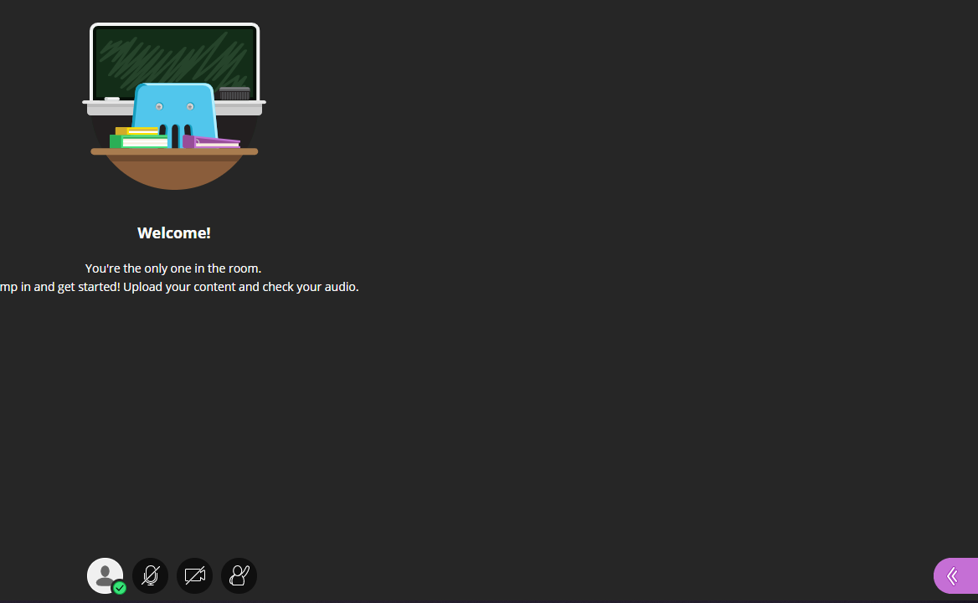

- Opening the tab allows you to access helpful tools.
  - Chat
  - Sharing
    - Files
    - Screen
    - Whiteboard
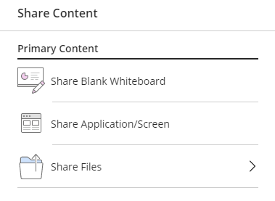

- Tutoring sessions are capped at 5 students at once. You may be working with a tutor one-on-one or with other students. If a tutor has more than one student in a session, they will work with each student in turn.

- If you have any technical issues during your session, please contact us at (806) 742-3664. Usually just restarting your device fixes most issues.

