SEF Application Download Instructions

Before you begin:
To view and complete the SEF Application, it is best to view the file in either Adobe Acrobat Pro or Adobe Acrobat Reader. If you do not have those installed, go here to download: https://get.adobe.com/reader/

Firefox Instructions:
- Click on the SEF Application link (https://www.depts.ttu.edu/staffsenate/SEF_Application.pdf).
- In the window that pops up, select “Open With Adobe Acrobat”.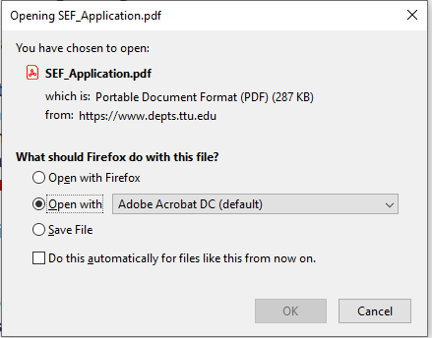
You should now see the application for you to complete.

Chrome / Edge Instructions:
- Click on the SEF Application link (https://www.depts.ttu.edu/staffsenate/SEF_Application.pdf).

- Save the file in a location that you can easily find. Make note of the folder path at the top of the window, as well as the file name in case you need to find it later.
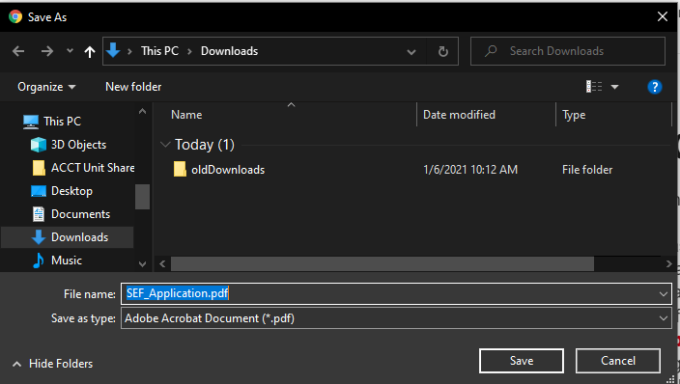
- At the bottom of the window, you should now see your downloaded file, click on the up arrow (Chrome) or 3-dot icon (Edge) next to file name and select “Show in Folder”.
Chrome:
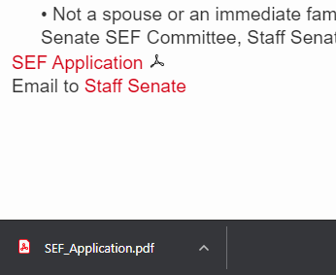
Edge:
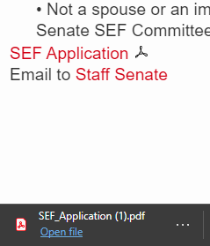
- You should see the SEF_Application.pdf file listed here, and can open it in Adobe Acrobat or Adobe Reader as needed: 