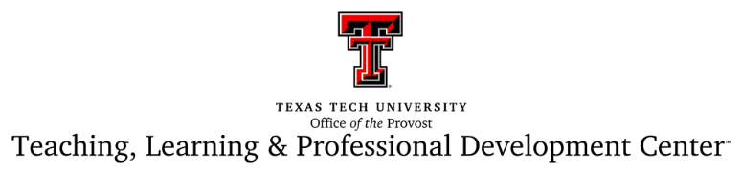

PERSONAL STATEMENTS OF STUDENT SUPPORT
OPTION 2

I stand firm in my support of all students at Texas Tech University and my commitment to educating and empowering a diverse student body. If you’re not sure of where or how to find resources to support your success here at TTU, please don’t hesitate to reach out to me. Here is my preferred method of communication: (insert email, phone, Blackboard, etc.).

